07.02 Hangar & Resources
Process Design & AMOS Configuration Document
Revision
Author, Name | Date | Notes
DEOS | 17.05.2024 | Initial issue
FREL | 02.06.2025 | Rev 01

Purpose
This Process Design document is provided to Key-Users to record their key decisions regarding the AMOS Process design and the required AMOS configuration.
It is updated throughout the Project Definition Phase and used as the baseline for the Final Acceptance prior to Go-Live

Table of Contents
1. Process Overview & Objectives 3
2. Regulatory References 3
3. Definitions & Glossary 4
4. Process Tasks 5
5. Process Dependencies 5
6. Process Flow 7
7. Process Design Questions 8
8. Data (Source) Mapping 9
9. Other Software Used 9
10. AMOS Configuration 9
a. Basic Data 9
b. Parameters 10
c. Workflows 10
d. Scheduled Tasks 11
e. API’s & Interfaces 11
11. Annex – Additional Info 11

Process Overview & Objectives

Process General Description:
This process is usually executed by the Production Planning and Human Resources department of an MRO or an Airline.
The Hangar & Resources process is a requirement to then be able to use the production and capacity planning features in AMOS. This process is executed each time there is a change in the resources of the organisation. A resource can be a hangar a tool or a staff. This process is continuously executed.
The trigger for this process is a change in a resource in the organisation.
The main benefits identified for the organisation when fully adopting this process are the following:
- Planning features: Adopting the Hangar & Resource process is one of the main mandatory steps to be able to do perform capacity and resource planning and assignment functions in AMOS. Without this process it is not possible to define resources and capacities which will then be used in the calculations.
- Quality gates: By properly defining your staff resources in the system you may then benefit from the quality gates used for sign offs in the various events defined in APN 10.
- Making resources available for reservation: Once defined as resources, the AMOS users may then book these resources against events, allowing for better planning and communication within the organisation.
Main Process Objective (Outputs & Outcomes):
The main stake holder involved in this process is the Production Planning and Human Resource departments.
The human resource department usually takes care of the staff definition in APN 146, taking care of defining the staff with the right qualifications, shift information, home base, etc.
The production planning department is then responsible to define the facilities used in the various bases of the organisation.
The main inputs for this process are:
- List of facilities and their applicable configurations
- Staff lists, approvals, qualifications, and other details
- Tool listing that are required in the capacity planning.
The main output for this process is to have all the relevant resources defined correctly within AMOS and readily available to be used in the capacity and production planning features.

Regulatory References

The following regulatory references are linked to this business process:
- EASA Part-145 145.A.25 – Facility requirements
- EASA Part-145 145.A.30 – Personnel requirements
- EASA Part-145 145.A.35 – Certifying Staff & Support Staff
- EASA Part-145 145.A.40 – Equipment and tools
- EASA Part-145 145.A.47 – Production planning

Definitions & Glossary

Key-Words | Explanation
Staff Qualification | A qualification is setup of Qualification Class and Type(s), e.g.  The class regards “Licenses” and the type defines the different type of licenses, like B1, C, etc. a staff might have.
Skill | A Skill is a resource that is required to be present, without an estimate or actual workload, quantified in manhours. Typical Skills are specific licences or combinations with ratings or other qualifications, e.g. ground run. Skills is quantified in Estimated Man.  Example: To release the aircraft after maintenance, at least a B1 licenced engineer is required. There is no indication about the estimated manhours in this case.  The various skills can be defined in APN 18 - Basic-Data Administration - Planning Qualification.
Scope | A Scope is a resource that can be quantified in Estimated Manhours, necessary to execute the work.  Example: To perform a certain work, staff is required that can perform electrician- and mechanical work. The resource planning would indicate that a scope of ELECT* and MECH* with a certain amount of manhours is required.  To be defined in APN 18 - Basic-Data Administration - Planning Qualification.
Shift planning | The Shift Planning is the process that manage the shift patterns already defined, in order to comply with planned Workpackages and estimated demands.  Adjustments of Shift plans are made as a result of Capacity Planning and by managing Staff Requests (Holidays, Overtime, Shift changes, etc.)
Multiple Qualification | An employee with several qualifications can be planned for several jobs obviously not at the same time. In Amos, in APN 148 - Staff & PQS Configuration, it is possible to define a Qualification Priority that will allow to better manage the possible assignments considering the various qualifications of the same technician. This Qualification Priority will only be used if in APN 2323 - Resource Planning or in APN 30 - Workpackage Browser the "Qualification" option will be set on "Multiple - Optimistic" or "Multiple - Pessimistic". If the "Main" qualification option will be selected, Amos will only take into account the value set in the Main Qualification field in APN 146 - Staff Management.
Main Qualification | Can be defined in APN 146 - Staff Management and means, if B1 is defined as main qualification and in APN 2323 - Resource Planning or in APN 30 - Workpackage Browser the option "Main" is selected in the Qualification field, employee can only be planned for B1 license work, even though he maybe hold as well license B2. With the other two available options (Multiple - Optimistic or Multiple - Pessimistic) Amos will consider all the available qualification of each resource.
Main / Multiple Optimistic / Multiple Pessimistic | In APN 2323 - Resource Planning in the Overview Tab or in APN 30 - Workpackage Browser in the HR Planning Overvew Tab, there are three ways of showing the qualification of a user. The options Multiple Pessimistic and Multiple Optimistic take into account all Staff Management licences. If an employee holds a B1 and B2 licence they can be planned for B1 or B2 work. As the planner cannot know which type of work the employee will be assigned in advance, the minimum and the maximum availability will be calculated.  Example If an employee has several licences, they cannot cover different tasks at the same time. In order to show you their availability, AMOS shows that they are, in the best case, 100% available and in the worst case 0% available.  The Qualification calculation logic is based on the same named field in Staff Management. If an employee holds the B1 as their main qualification, they can only be planned for B1 work even if he also holds a B2 licence. This allows you to plan manpower exactly.
Productivity | The productivity in AMOS can be set per user. AMOS considers only hands on A/C personnel as “productive”. Productivity entries can be between 0-100, 100 meaning all presence time can be planned as hands on A/C work. Shift leaders, etc. will have lower productivity levels as their tasks also contain administrative work.  You can enter/adjust the Productivity in the APN 146 - Staff Management.

Process Tasks

Main Process Task / Actions / Activities:
The following actions are performed in this Business Process:
- Address & Station definition: Define an address for it to be identified as a facility to allow the system to include it in the facility definition.
- Facility Definition – (Configuration, Hangar, Aircraft Pics): Once the facility item defined, create the hangar configurations, add the relevant aircraft pictures, define the possible hangar configurations.
- Hangar Slot Resource definition: For each slot, define the equipment available and the slot properties.
- Resource Property & Planning relevance definition:
- Staff member definition: Setup the staff in the staff administration APN. This includes but is not limited to defining departments, homebase, job, productivity and pensum levels, and qualifications.

Process Dependencies

The following dependencies are present for this process:
- 04.03 – Trainings and Qualifications: to be able to correctly define the qualification and currency of a specific staff resource, the training and qualifications of the staff need to be setup in the system. This will then allow to benefit from these to define user scope and capabilities.
- 07.01 – Shift Planning: When using shifts to define staff availabilities, the setup must include shift planning definition and assignment functions to render the resource available when they are planned to be.
- 07.05 – Resource & Staff allocation: once defined correctly the resource is available in the various production planning a resource assignment APNs, to allow for proper capacity planning and staff reservation and allocation.
- 09.03 – Ordering: Once the new tool is defined, it is required to order it, hence this needs to go through the Ordering process.
- 10.02 – Receiving goods: Once the tool is ordered and received, it needs to go through the standard receiving process to be made available as a resource within the customer environment.
- 01.02 – Parts Definition: This process is mandatory to define new tools when this new resource type is required in the organisation.

Process Flow

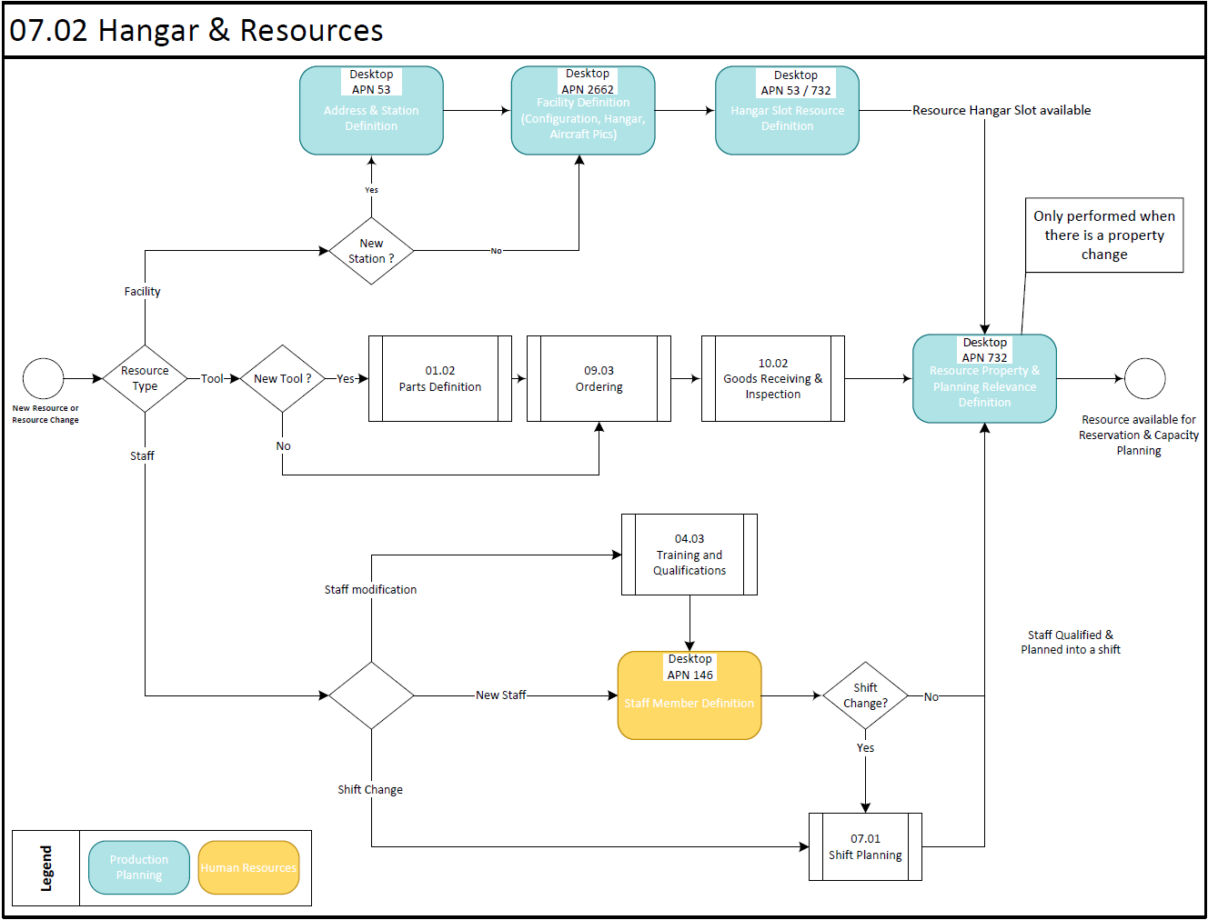
This flow chart is based on three different main paths:
- The Facility path – to be followed when defining a new facility or a change of a facility which is a resource.
- The Tool path – to be followed when a new tool is required as a resource.
- The Staff path – to be followed for all staff relevant resource changes.

Process Design Questions

# | Question | Answer
1 | Do you use shift planning within your organisation?
2 | Do you have Shift planning / Resource Manager role in your company?
3 | How do you calculate your Capacity today?
4 | Which specific items (facilities, tools, staff coverage) do you want to be able to plan capacity wise?

Data (Source) Mapping

Data Sources | Description | Volume / Manual / Automatic / Static / Dynamic
-Nil-

Other Software Used

Other Softwares | Used by: | Description
-Nil-

AMOS Configuration

Little AMOS configuration is generally required for this process. The main configuration items are linked to the setup of the different qualification types and address types to be used for the definition of the resources.

Basic Data

Basic Data Table | Notes
Planning Qualifications | To define Skill and Scope by staff specialty or qualification in order to properly perform a work instruction.  Skill e.g. : C, B1, B2 etc...  Scope : Mech., EIR, Cabin,
Meta Data Key | Basic Table to define the applicable meta keys which can be used when defining new meta data.  If a `Mime type` is added the user is able to choose the meta data value via book when adding a value
Address Property Type | This table contains the Address Property Types to be used in program Address Administration, tab she...
Address Type | Address type definition which is used in Address Administration for a certain address. So an address...

Parameters

Parameter Code | Parameter Name | Notes | Settings
1404 | Use Shift plan in Planning Modules | With this parameter you can control if the shift plan taken from the AMOS shift planning modules should be used to calculate the availability of human resources or not. | Float: 0  Integer: 0  String: Y
1422 | Qualification visible | This parameter defines the qualifications visible in the popup menu "Qualifications" used in the different programs of the Shift Planning module. This popup menu is displayed when selecting a user sign. The qualifications are defined in PQS Basic Data as Event Classes  To define the qualifications visible, set this parameter to the value of the different Event Classes needed.  It is possible to combine different values by separating them with a ; character, for example TAU;ML | Float: 0.00  Integer: 0  String: As required

Workflows

Workflow Number | Workflow Name | Notes
161 | New Address Stored | This workflow is triggered when a new address will be stored.
162 | Address Property Stored | This workflow is triggered when an address property will be stored.
200 | Check Qualifications Expiry Date (Scheduled Task) | This workflow is triggered, when a qualification will expire for an employee.
202 | Check Qualifications Expiry Date (HR Modules) | This workflow is triggered, when a qualification will expire for an employee.
226 | Employee has been deleted | This workflow is triggered, when an employee has been deleted.
229 | Address saved (pre-save) | This workflow is triggered before an address is saved.
453 | Address saved (post-save) | This workflow is triggered after an address is saved.

Scheduled Tasks

Scheduled Task Reference | Frequency | Notes
PqsExpiryCheck | Once a month | Check the expiry of staff qualifications

API’s & Interfaces

Reference | Direction | Trigger | Frequency
-Nil-

Annex – Additional Info

-Nil-

